Inverse problems and environment

Some new tools for atmospheric studies

University of Namur, Department of Mathematics

From Monday 10 to Wednesday 12 March 2014

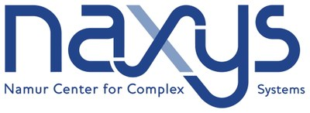
IAP VII/19 – DYSCO

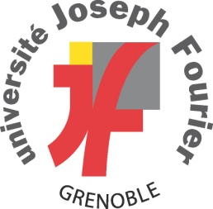

Inverse problems and environment:

Some new tools for atmospheric studies

From Monday 10 March 2014 at 8h30 to Wednesday 12 March 2014 at 17h00

Abstract:
Global warming is now unequivocal, as mentioned in the IPCC Fifth Assessment Report (November 2013). This climate change can be monitored and analyzed, for example, by understanding the warming of the atmosphere and the recent evolution of greenhouse gas. The complexity of the dynamics and the sparsity of the measurements (e.g. direct measurements of the atmosphere or trace gas measurements in ice cores) necessitate advanced methods to reconstruct the past events. The aim of this school is to introduce recent modeling and inverse techniques for solving such key environmental problems with high societal impact. It will emphasize the need for an interdisciplinary approach involving environmental science, optimization, numerical analysis and signal processing. The classes are intended for a broad audience with basic mathematical background (e.g. calculus and differential equations).

This school is a joint activity of the graduate schools (Ecoles Doctorales Thématiques (EDT) MATH and COMPLEX of the Fonds de la Recherche Scientifique – FNRS
http://www1.frs-fnrs.be/index.php

Location:
The school is organized at the Department of Mathematics of the University of Namur (UNamur), room E25, 2nd floor.
The Department of Mathematics is located in the building of the Faculty of Economics, Social Sciences and Business Administration (building number 2 in the map below), 8 rempart de la Vierge, B-5000 Namur.

UNamur Campus

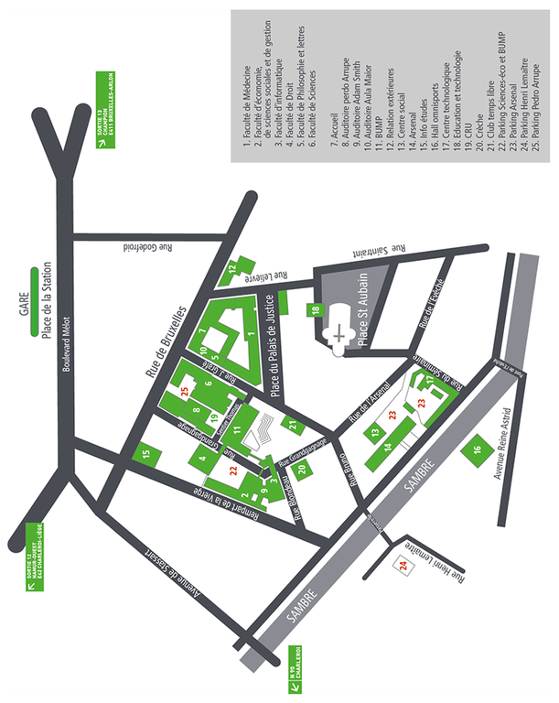
Lecturers:
Anne De Wit, Laboratoire de Glaciologie, Université Libre de Bruxelles (ULB), Brussels.
Sander Houweling, SRON Netherlands Institute for Space Research, Utrecht, NL - Institute for Marine and Atmospheric Research (IMAU), Utrecht University, NL.
Maarten Krol, SRON Netherlands Institute for Space Research, Utrecht, NL - Institute for Marine and Atmospheric Research (IMAU), Utrecht University, NL - Department of Meteorology and Air Quality (MAQ), Wageningen University and Research Centre, NL.
Franck Pattyn, Laboratoire de Glaciologie, ULB, Brussels.
Annick Sartenaer, Namur Center of Complex Systems (naXys) and Department of Mathematics, University of Namur, Namur.
Stefan Vandewalle, Division of Numerical Analysis and Applied Mathematics, KULeuven, Leuven (Heverlee).
Emmanuel Witrant, Division of Numerical Analysis and Applied Mathematics, KULeuven - Automatic control department, GIPSA-lab/Université Joseph Fourier, Grenoble, France - Laboratoire de Glaciologie, ULB, Brussels.

Local organizers:
Timoteo Carletti and Joseph Winkin, naXys and Department of Mathematics, UNamur.

Scientific coordinator:
Emmanuel Witrant.

Program
Day 1 – Monday 10 March 2014
8:30 Welcome (Joseph Winkin/Timoteo Carletti)
9:00-10:00 Introduction and basic modeling concepts (Emmanuel Witrant, 1h).
Overview of inverse problems; Conservation laws and modeling with partial differential equations; Some computation issues; The advective vs. diffusive dilemma.
10:00-10:15 Coffee break
10:15-12:15 The earth system: from proxies to decision making (Sander Houweling).
The climate system; Atmospheric transport models and feedback mechanisms; Measurements and proxies; The role of Methane and Carbon dioxyde; Assessing climate changes.
12:15-13:30 Lunch
13:30-15:00 Optimization methods: problem formulation (Emmanuel Witrant). Performance measure and information content in the data set (cross-validation), optimality principle, calculus of variations.
15:00-15:15 Coffee break
15:15-16:45 Optimization methods: analytical and numerical solutions (Emmanuel Witrant).
Optimizing dynamical systems; Solving linear problems; Nonlinear programming and gradient descent; Numerical methods.

Day 2 – Tuesday 11 March 2014
9:00-10:30 Chemo-hydrodynamic patterns and instabilities (Anne De Wit).
Hydrodynamics instabilities in reactive systems; Effect of chemical reactions on density and viscous fingering; Convective instabilities in sea ice and during CO2 sequestration in porous media.
10:30-10:45 Coffee break
10:45-12:15 Inverse modeling from ice cores (Emmanuel Witrant).
Modeling heterogeneous transport of trace gas in a 1-D porous medium; Characterizing transport in ice cores using PDE optimization; Atmospheric reconstruction of trace gas from linear optimization and sparse data.
12:15-13:30 Lunch at the Arsenal on the occasion of the ‘’Défi Lasagnes’’ that is organized in the framework of the ‘’Télévie’’. The ‘’Télévie’’ is organized every year for collecting funds in order to support medical research, especially projects that are devoted to cancer.
13:30-16:15 (inc. coffee break) Inverse modeling of atmospheric emissions (Maarten Krol).
Measurements calibration and correlation; Handling uncertainties; Cost function and regularization; Qualitative analysis and methods revision, sensitivity analysis. Hands-on simulation experience.

Day 3 – Wednesday 12 March 2014
9:00-10:30 Optimization techniques in data assimilation for oceanography and weather forecasting (Annick Sartenaer).
The variational approach and its 4D-Var formulation; Preconditioning techniques; Derivative-free approaches; Multilevel optimization.
10:30-10:45 Coffee break
10:45-12:45 Glaciers, ice sheets and ice shelves (Frank Pattyn).
Ice-sheet modelling; Common approximations of the Stokes equations; Numerical solutions; Initialization problems and boundary condition estimate using inverse modeling.
12:45 – 14:00 Lunch
14:00-16:15 (inc. coffee break) Analysing and simulating large-scale systems (Stefan Vandewalle).
Methods from numerical analysis for complex (possibly nonlinear) systems described by partial differential equations, multigrid approaches.

